

**Cloud Deployment Models**

**Name:** Pratham Kandari

**Sap Id:** 500097663

**Batch:** 7

**Experiment -1**

***Introduction to OPENGL***

1. What is OPENGL?

Ans: A cross-platform, cross-language application programming interface (API) called Open Graphics Library is used to render 2D and 3D vector graphics. For hardware-accelerated rendering, the API is commonly used to communicate with a graphics processing unit (GPU).

Any visual element you put on the screen is fair game for OpenGL, whether it is to handle embedded video, generate vector graphics, or make UI animations more responsive. Developers must grasp how to take advantage of OpenGL's amazing potential because it is becoming more and more commonplace.

1. What is GLU/GLUT?

Ans: A computer graphics library for OPENGL is called the **OpenGL Utility Library (GLU)**. It consists of a number of functions that leverage the OpenGL foundation library to give more advanced drawing routines than what OpenGL offers. The glu prefix is the first letter of every GLU function.

The Window System Independent OpenGL Utility Toolbox is a toolkit for creating OpenGL programmes. It implements an easy-to-use windowing OpenGL application programming interface (API).

1. OpenGL Framework?

Ans:

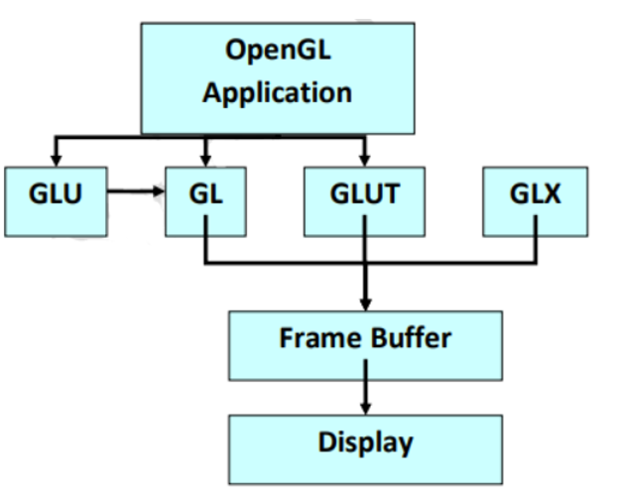

1. OpenGL Architecture?

Ans: The client-server concept serves as the foundation for OpenGL's architecture. The "client" runs on the CPU and is an application programme created to utilise the OpenGL API.

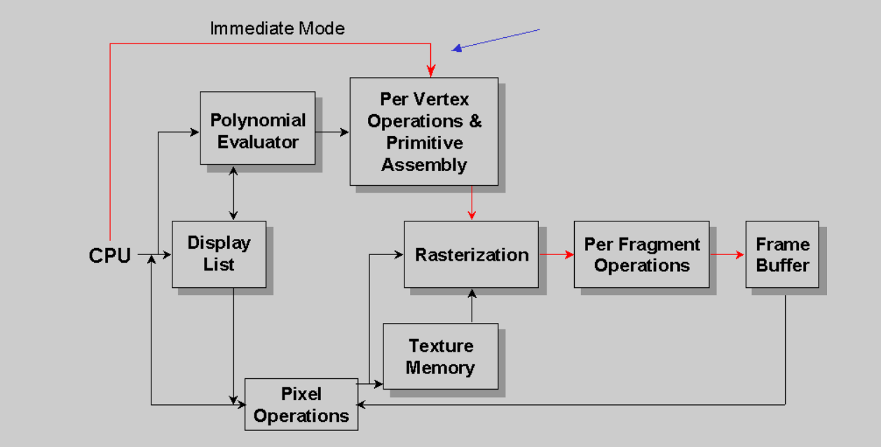

1. OpenGL Window Manager Interfaces?

Ans: With glfwCreateWindow, which provides a handle to the newly generated window object, a window and its OpenGL or OpenGL ES context are produced. For example, this creates a 640 by 480 windowed mode window: GLFWwindow* window = glfwCreateWindow(640, 480, "My Title", NULL, NULL);